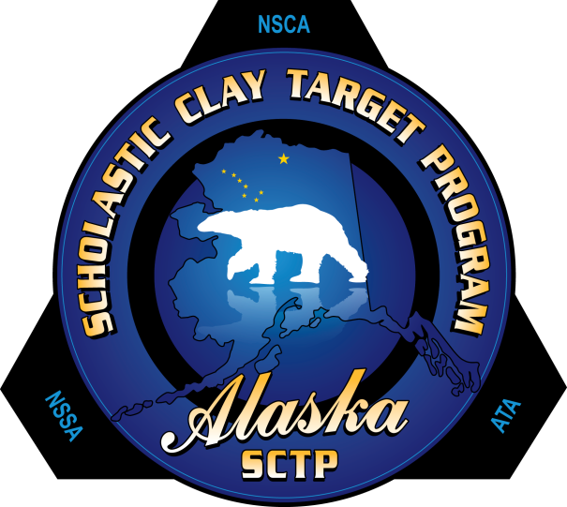
2013 Clay Target Safari

Tues-Friday: 100-Bird Trap and 100-Bird Skeet
Saturday: 100-Bird Sporting Clays Walkthrough
$150 Registration includes Awards Banquet on Saturday

3-Man Squads & Individual Awards in 5 Divisions in All 3 Disciplines + Overall!
180 Medals ~ 20 Trophies ~ 18 Awards ~ $56,000 MidwayUSA Endowment Funds Awarded
For more information see your Head Coach or call Neil Moss at 373-0961

